Where We Live NYC
Draft Plan

Executive Summary

What is the draft plan?
Through Where We Live NYC, the City has developed a draft plan to take bold, transformative action to break down barriers to opportunity and build more integrated, equitable, and inclusive neighborhoods. Intentional policies and practices created segregation and inequity across the country and in our city, and it will take concerted effort from all levels of government, working with our partners in the private and non-profit sectors, to undue that legacy. This executive summary presents an overview of the fair housing challenges that New York City currently faces and the goals and strategies that the City plans to undertake to address these challenges. Please refer to the full draft plan for more detailed analysis. We need feedback to make sure the draft plan reflects the right analysis and goals before releasing a final plan this winter

This draft plan seeks to
- Combat persistent, complex discrimination with expanded resources and protections
- Facilitate equitable housing development in New York City and the region
- Preserve affordable housing and prevent displacement of long-standing residents
- Enable more effective use of rental assistance benefits, especially in amenity-rich neighborhoods
- Create more independent and integrated living options for people with disabilities
- Make equitable investments to address the neighborhood-based legacy of discrimination, segregation, and concentrated poverty

What is Where We Live NYC?
Where We Live NYC is the City of New York's comprehensive fair housing plan process. Through Where We Live NYC, the City is working collaboratively with residents and community leaders to:
- Fight discrimination
- Confront segregation
- Take action to advance opportunity for all

What is fair housing?
The fight for fair housing has a long history in New York City and nationwide. Here are three things you need to know:
- The Fair Housing Act (1968) comes out of Civil Rights Era activism and protects you from discrimination when you are renting, buying, or financing your home, based on your:
  - Race
  - Color
  - National origin
  - Religion
  - Sex
  - Disability
  - Family status
- The City of New York passed the nation’s first local law against housing discrimination in 1951. Today, the New York State and New York City Human Right Laws are some of the strongest in the country. They include additional protections based on:
  - Age
  - Citizenship
  - Lawful job or source of income, including rental assistance
  - Gender, gender identity, or gender expression
  - Marriage or partnership status
  - Current children or plans to have children in the future
  - Sexual orientation
  - Experience as a survivor of domestic violence, stalking, or sex offenses
  - Military service
- The Fair Housing Act also requires cities to affirmatively further fair housing. This mandate is the inspiration behind Where We Live NYC. To advance fair housing, the City designs policies and invests resources to:
  - Empower people to move to the neighborhood of their choice or stay in their current neighborhood, even as it changes
  - Ensure that all communities have the resources they need to thrive

Where do New Yorkers live?
A long history of housing discrimination has impacted your neighborhood and the residential patterns of racial groups across our city. By some measures, New York City’s neighborhoods are becoming more diverse, yet no neighborhood currently reflects the full diversity of the city.

Where We Live by Race and Ethnicity
This map shows that there are parts of New York City with significant diversity among the four major racial and ethnic groups, while each group is also clustered in different parts of the five boroughs.

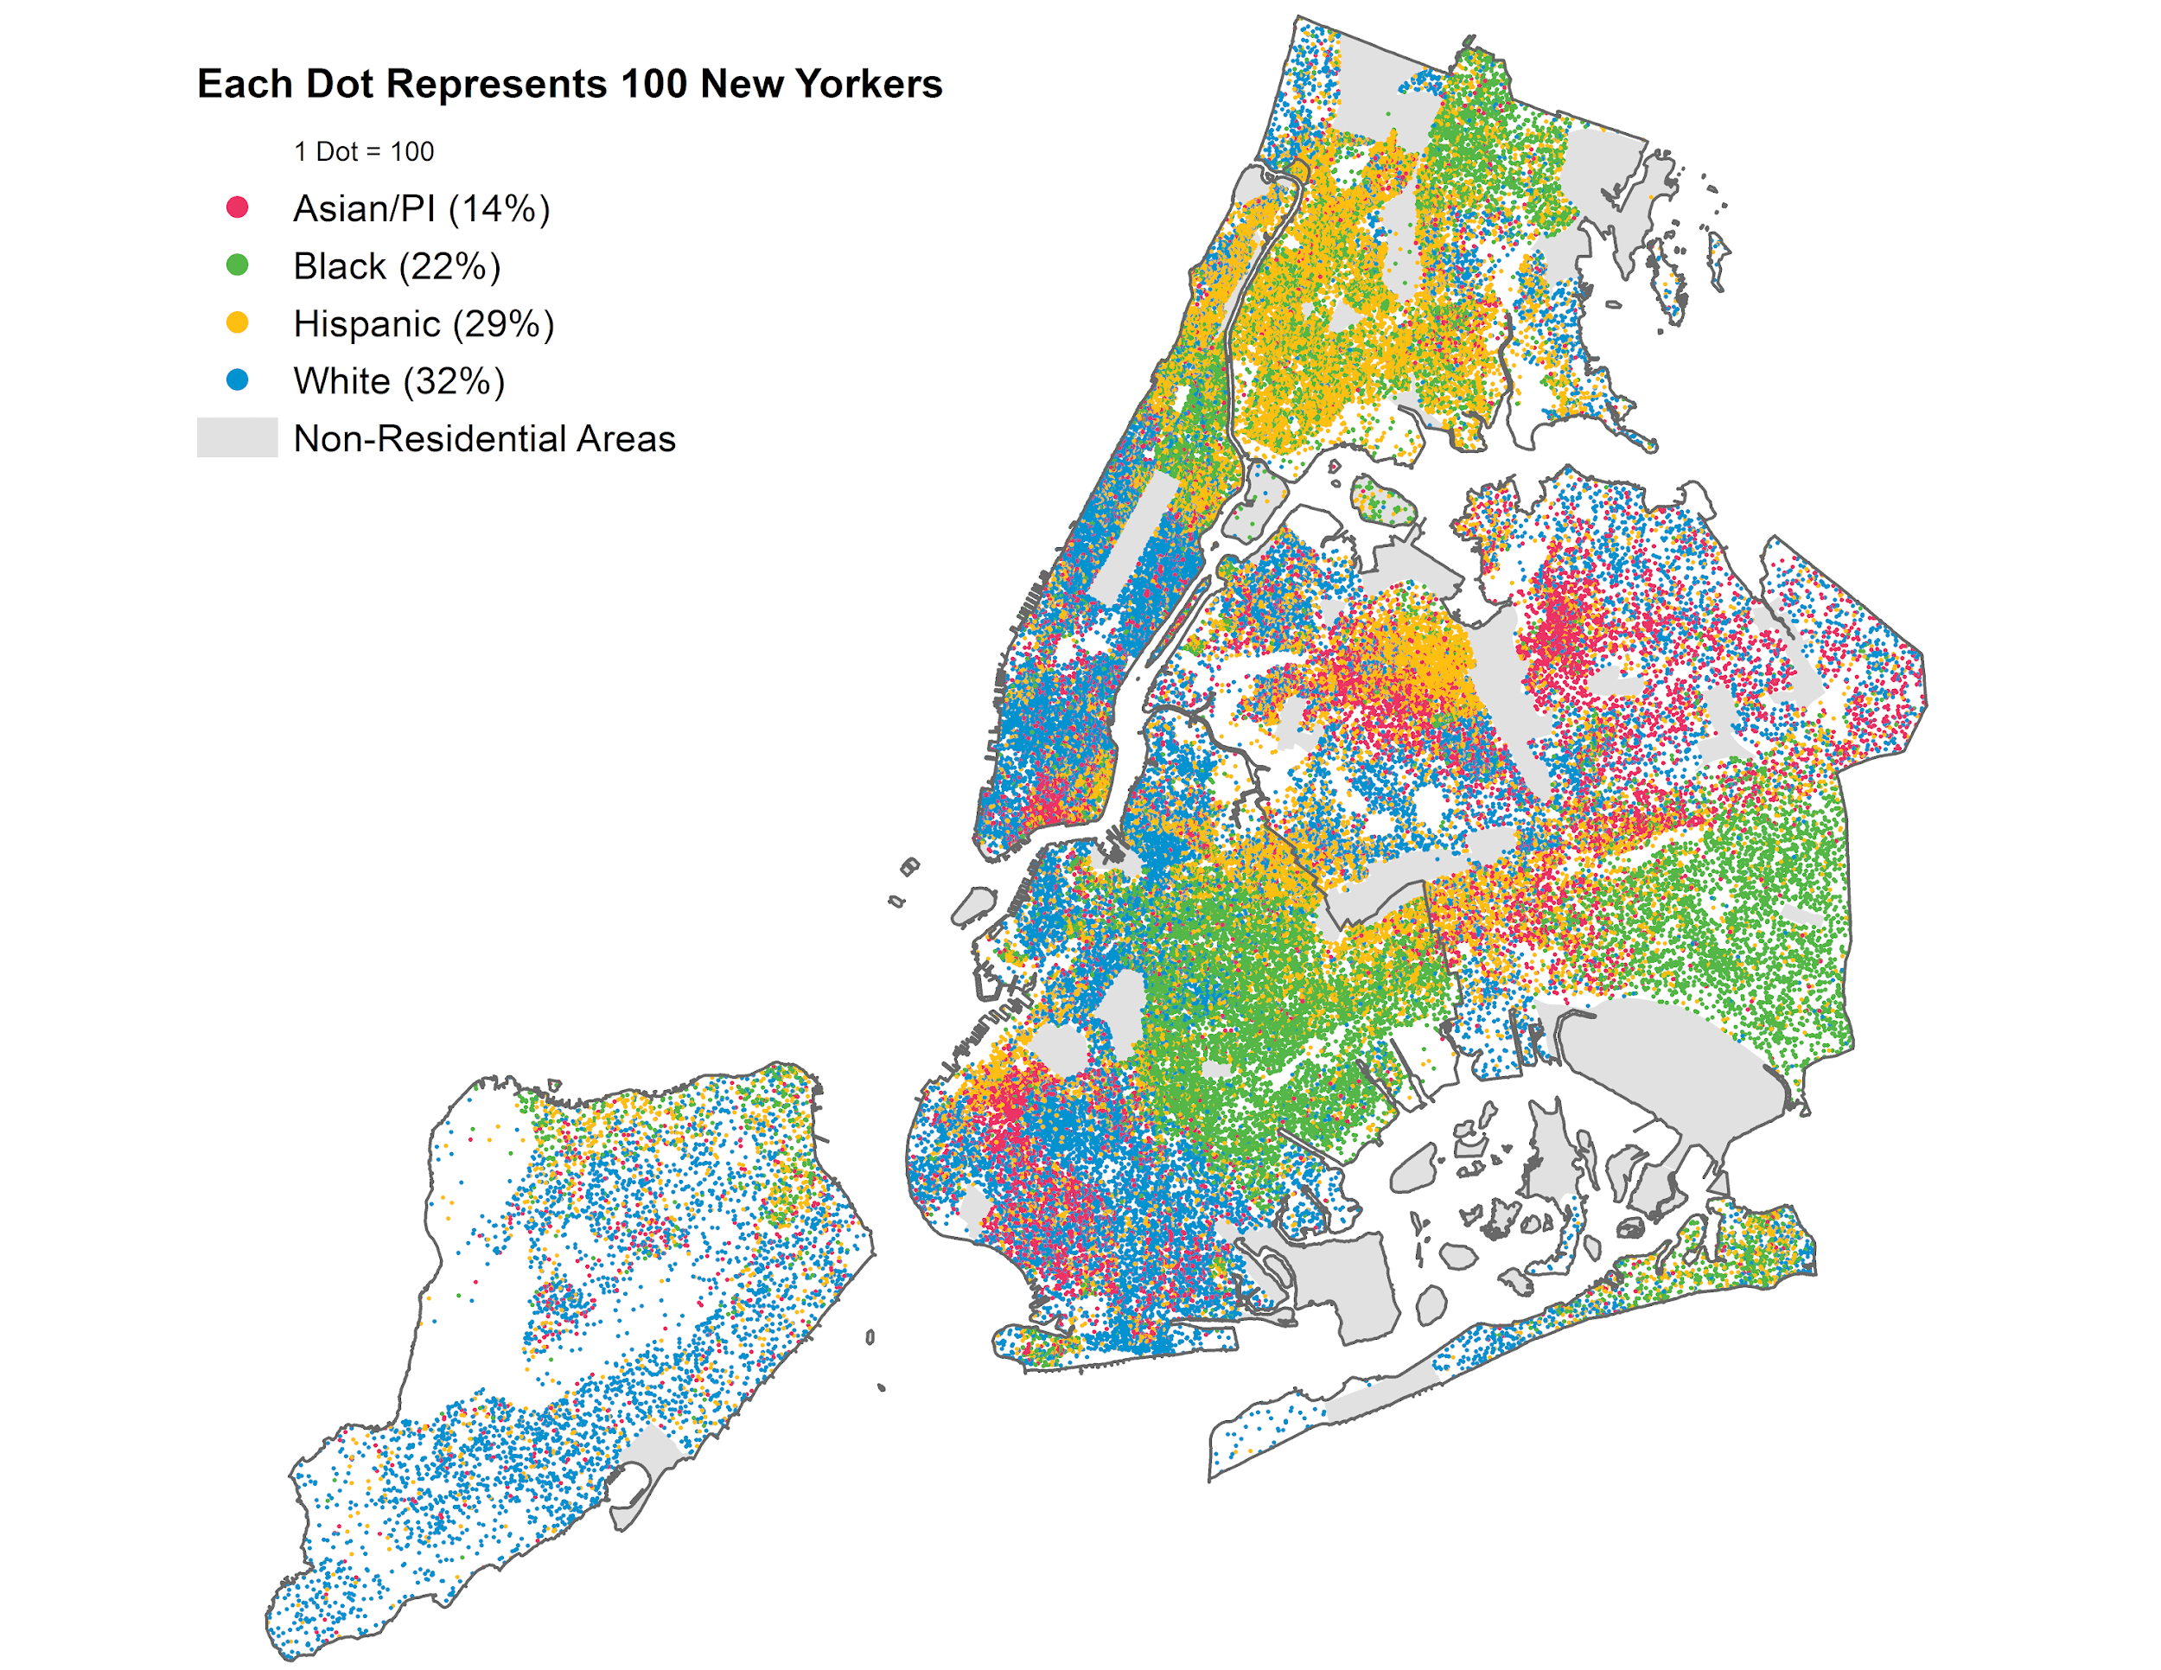
Source: ACS 2012-2016, five-year estimates, Table B0300 tract level data.

Why does fair housing matter?
Not all New Yorkers have equal access to opportunity due to historic and present-day injustices, which especially impact communities of color and people with disabilities.

The History
The fair housing challenges that New York City faces today are rooted in the nation’s history of slavery and racist laws, policies, and practices. Jim Crow laws did not only exist in the South. They also existed in New York City, restricting where residents could live, work, and even the pools where they could swim. As immigrants made their homes across the five boroughs, they also experienced discrimination and segregation. The treatment of people of color—and particularly Black New Yorkers—as second-class citizens has had real and lasting impacts.

Today
New York City is the most diverse city in the country and New Yorkers today live in neighborhoods that are more racially and economically diverse than the past, but housing discrimination and segregation in our neighborhoods persist. There are clear, ongoing connections between a New Yorker’s race, where they live, and their access to opportunity— including access to quality schools, reliable transportation, healthy environments, and economic opportunity. Inequalities also exist for people with disabilities.

Moving Forward
While we still have a long way to go to create a city that is equitable for all, many important milestones have been reached over the last few years, including:
- Securing one of the nation’s strongest mandatory inclusionary housing programs, so wherever housing is built through zoning changes, between 20 and 30% of that housing will be permanently affordable
- Enrolling 70,000 children in the 2018-2019 school year in Pre-K for All and narrowing the gap in test scores between White and Black students and between White and Hispanic students
- Making over 400 parks more accessible to residents with disabilities
- Allocating over $800 million to make schools more accessible to students with disabilities
- Conducting community health profiles to identify and address the root causes of health inequities driven by neighborhood context and other social determinants of health

Charting Race, Place and Poverty
As this chart shows, White New Yorkers are the only group overrepresented in parts of the city with low rates of poverty. White New Yorkers therefore disproportionately benefit from living in neighborhoods that are more likely to provide better access to services, healthy environments, great schools, and experience lower crime.

Source: ACS 2012-2016, five-year estimates, Table B03002 for race/ethnicity and Table B07001 for poverty - tract level data.

How was this draft created?
As part of this process, the City undertook extensive analysis and invited wide public participation to better understand how fair housing challenges like segregation, discrimination, and lack of access to thriving neighborhoods impact New Yorkers’ lives and how the City can eliminate barriers that currently impede fair housing. The project includes several key components:
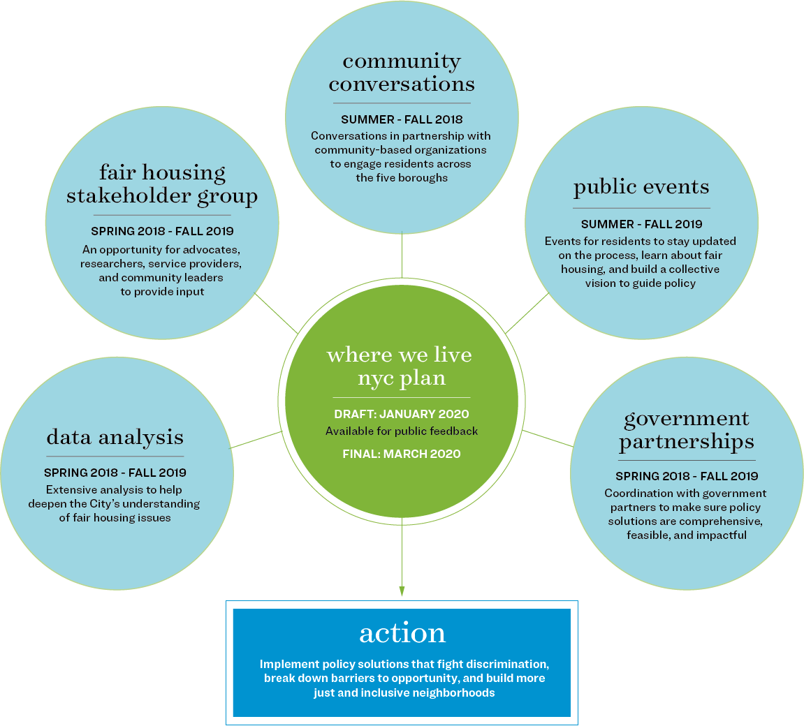

About the team
Where We Live NYC is led by the Department of Housing Preservation and Development (HPD), in partnership with the NYC Housing Authority (NYCHA) and in close collaboration with numerous additional government partnerships. The City partnered with Hester Street and community-based organizations to lead the Where We Live NYC Community Conversations with residents across all five boroughs. Partnerships include:
- Ali Forney Center
- Arab American Association New York
- Asian American for Equity
- Banana Kelly Community Improvement Association
- Brooklyn Center for Independence of the Disabled
- Center for Court Innovation
- Center for the Independence of the Disabled New York
- Chhaya CDC
- Fifth Avenue Committee
- Make the Road New York
- Neighbors Together
- SAGE Advocacy and Services for LGBT Elders
- Sapna New York City

Goal One: Combat persistent, complex discrimination with expanded resources and protections
Discrimination against New Yorkers looking to rent, buy, or get a loan for a home is still a widespread practice that unfairly limits housing and neighborhood options for many.
Ending discrimination in its different forms is not easy. That’s why the City is taking a multi-faceted approach through increased enforcement and protections to address the complex and persistent discrimination that still occurs in the housing market.

Why does this matter?
The City of New York led the nation in passing fair housing laws in the 1950s, yet discrimination remains a major challenge 60 years later.
During the Where We Live NYC process, New Yorkers shared experiences of discrimination by landlords, brokers, and other real estate professionals.
Some have experienced explicit discrimination based on their race or disability, while others shared indirect or masked forms of discrimination— like unanswered calls, receiving incorrect or misleading information about apartment availability, or facing barriers like inconsistent fees, credit checks, or income requirements that can be used to limit who has access to housing. Such stories are consistent with the complaints made to the City.
In 2018, the NYC Commission on Human Rights filed 280 complaints alleging housing discrimination and conducted 481 tests to search for discriminatory actors.

Goal One Draft Strategies

Strengthen New York City’s Fair Housing Enforcement
- Increase proactive enforcement to prevent discrimination and ensure that landlords, home sellers, banks, and brokers are following the law
- Expand resources for addressing fair housing complaints, with a focus on supporting people with disabilities and residents using rental assistance
- Explore new regulations to address discrimination by co-op associations

Expand New York City’s Fair Housing Protections
- Explore ways to prevent unfair treatment of New Yorkers who have been involved in the criminal justice system
- Help implement critical new legislation passed by New York State that further protects residents using rental assistance from discrimination
- Explore opportunities to address financial barriers that may limit New Yorkers’ choices in the housing market or be used as forms of discrimination, like credit history, broker fees, and security deposits

What would this mean for you?
- More accountability for landlords, brokers, and lenders
- More resources available to address your fair housing complaints
- More support for New Yorkers with disabilities and residents using rental assistance, like vouchers
- Protections that ensure friends, family, and neighbors who may have been involved in the criminal justice system receive fair treatment when searching for housing

Goal Two: Facilitate equitable housing development in New York City and the region
New York City has a housing crisis. There is a growing population and rising demand for homes, but a limited supply. This makes it especially challenging for low-income New Yorkers, who are disproportionately people of color and people with disabilities, to find housing options that are affordable.
To affirmatively further fair housing, the City must ensure that residents have realistic options to live in a variety of thriving neighborhoods. This requires expanding housing options for low-income residents across New York City and the region.

Why does this matter?
Throughout the Where We Live NYC process, low-income New Yorkers shared that the high cost of housing dramatically limits their choice of homes and neighborhoods.
Because of limited affordability, residents reported compromising on poor conditions and overcrowding or limiting their housing search to neighborhoods that feel unsafe or have underperforming schools.
New York City’s housing crisis will only worsen without a significant increase in the housing options available in all neighborhoods. But there is growing local opposition to the development of housing, and this opposition can take different forms.
In areas with more wealth and amenities, opposition to new housing—particularly affordable housing—raises concerns since restricting new housing can limit access to the neighborhood for low-income residents and people of color. This type of opposition can also lead to perceptions of hostility and exclusion. Some New Yorkers of color shared concerns about discomfort, discrimination, or mistreatment when living in predominately White areas.
Opposition to housing also exists in historically under-resourced neighborhoods where residents fear that new housing development will make rents less affordable or increase the risk of displacement.
These different types of local opposition are one reason why New York City is falling behind in new housing production compared to other high-cost cities. As the chart (right) illustrates, Seattle permitted more than three times as much housing growth per 10,000 residents in 2018.
Using a fair housing approach, the City has a unique opportunity to work alongside communities to ensure that the development of new housing promotes choice and equity for all residents.

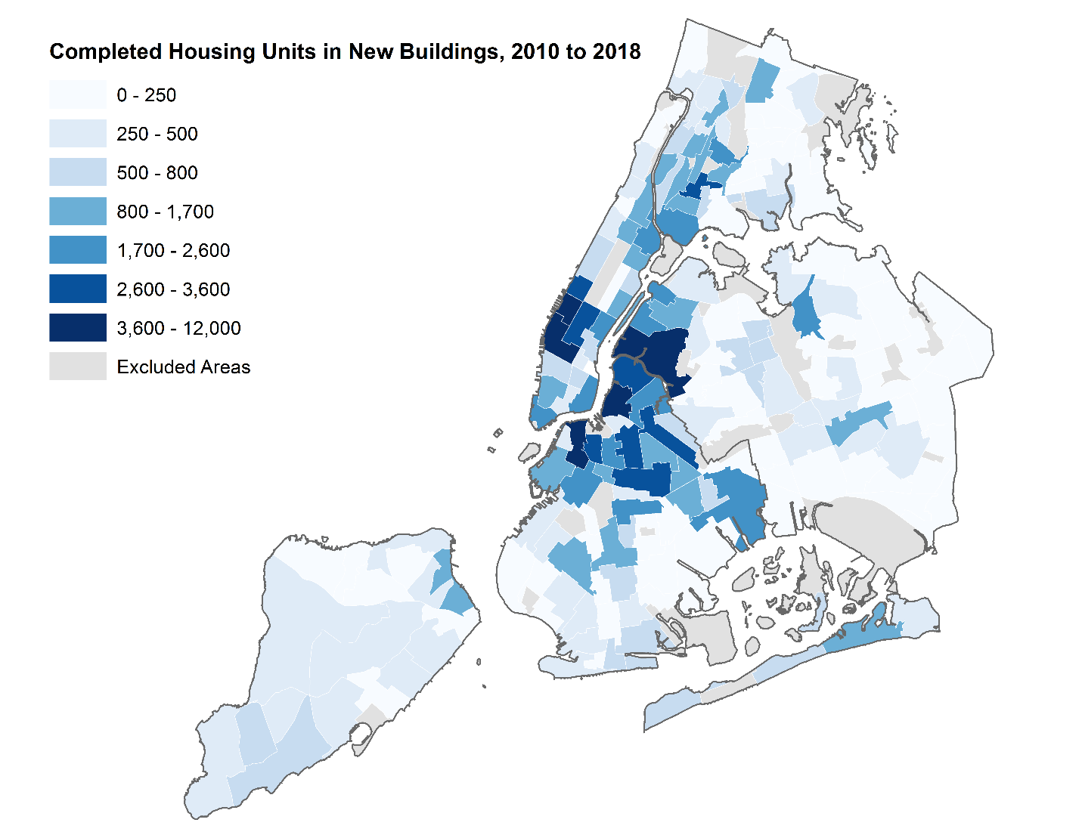
Source: NYC Department of City Planning Housing Database 19v1, March 2019. Compilation of NYC DOB Applications and Certificates of Occupancy data 2010-2018. Map shows completed housing units in new buildings 2010-2018, by NTA

Goal Two Draft Strategies

Introduce new opportunities to promote equitable housing growth
- Explore strategies that enable the development of affordable housing in areas that currently have limited affordable housing options, including zoning reforms, changes to state and local regulations, and new approaches to using the City’s limited housing subsidies
- Work with other local governments to develop a regional housing agenda
- Explore opportunities to collect and share data to thoughtfully evaluate the relationship between housing production, demographics, and access to opportunity across the city—and use this analysis to inform City decision-making and community engagement
- Work with Community Boards to promote inclusive and accessible practices in their outreach and decision-making processes

Open up government housing programs to even more New Yorkers
- Launch improvements to Housing Connect (the City’s affordable housing lottery) that make it easier to apply
- Expand the Housing Ambassadors program, which trains community-based organizations to support New Yorkers in searching and applying for affordable housing
- Ensure non-citizens and mixed-citizenship status families have the information they need to safely access government housing programs
- Ensure LGBTQ individuals feel safe using government programs, including homeless shelters and housing programs through improved training and protocols
- Support NYCHA’s efforts to reunite New Yorkers who have been involved with the criminal justice system with family members in NYCHA

What would this mean for you?
- More affordable housing available across New York City, including more options to move into neighborhoods that currently have limited housing opportunities for low-income New Yorkers
- Streamlined processes and more support to help you apply for affordable housing
- Better services for any friends, family, and neighbors who may be non-citizens, identify as LGBTQ, or have been formerly involved with the criminal justice system to help them safely access government housing programs

Goal Three: Preserve affordable housing and prevent displacement of long-standing residents
Promoting fair housing in a high-cost city also means supporting New Yorkers who want to stay in their home or neighborhood, even as it changes.
This is why it is critical to preserve existing affordable homes, including those in NYCHA and other rent-regulated buildings, while also supporting programs that protect tenants and homeowners from harassment and mistreatment.

Why does this matter?
Existing affordable housing is critical in providing housing and neighborhood choice for New Yorkers. While fair housing often focuses on the production of new housing, it is also important to invest in preservation as part of a fair housing strategy to ensure existing homes remain safe, stable, and affordable options for New Yorkers into the future.
Preserving and protecting affordable housing also means safeguarding the rights of tenants. New Yorkers made clear that discrimination and unfair treatment occur during interactions with their landlords and building management. Often targeted because of their identity, residents shared experiences of poor housing conditions, lack of repairs, harassment, physical violence, and intimidation. New York City homeowners also described experiencing unfair treatment, facing discrimination from banks and being targeted for exploitative financial products or even fraud based on their race and age.
New York City Housing Authority is critical to fair housing:
- The average monthly rent of a New York City Housing Authority apartment is $533
- There are more than 170,000 homes in the New York City Housing Authority, making up eight percent of all rental housing in New York City
- More than ninety percent of New York City Housing Authority residents are Black or Hispanic and nearly forty percent of households are headed by a New Yorker sixty-two years or older
- The majority of New York City Housing Authority apartments were built more than fifty years ago, between 1945 and 1970

Goal Three Draft Strategies

Preserve quality, affordable housing for existing residents
- Improve conditions in and operation of NYCHA’s more than 170,000 apartments, the largest source of permanently affordable housing in New York City
- Expand support for existing financing and assistance programs that help homeowners and small landlords keep affordable homes in healthy, livable conditions
- Provide targeted support to neighborhoods with high health-related risks, like asthma
- Explore further opportunities to support mission-based groups such as Mutual Housing Associations and Community Land Trusts

Protect tenants facing harassment and evictions
- Continue the citywide expansion of free legal services for tenants facing eviction in Housing Court and NYCHA proceedings and increase proactive outreach for the services
- Increase services to help tenants understand and navigate Housing Court
- Study anti-harassment initiatives to help inform how to best protect tenants in additional neighborhoods

Protect homeowners vulnerable to fraud and scams
- Implement new regulations to protect low-income homeowners from speculative investors, aggressive real estate solicitation, and scams

What would this mean for you?
- Resources to protect tenants against eviction and harassment
- Improved housing conditions for friends, family, and neighbors living in NYCHA and other affordable housing
- Increased protections for homeowners from speculation, scams, and solicitations

Goal Four: Enable more effective use of rental assistance benefits, especially in amenity-rich neighborhoods
Many New Yorkers use rental assistance and vouchers to secure safe, stable, and affordable homes. But, across the nation and locally, residents using vouchers often live in neighborhoods with higher levels of poverty and lower performing schools.
A crucial part of promoting fair housing is ensuring New Yorkers using rental assistance have access to a diversity of neighborhoods. This is why the City is seeking to open more housing options to New Yorkers using rental assistance and improve the design of the program to better serve participating residents and landlords.

Why does this matter?
Today, more than 130,000 individuals and families in New York City use rental assistance. Designed to provide more choice in the housing market, rental assistance programs offered by the city, state, and federal governments can be difficult to use, especially in more expensive neighborhoods.
During the Where We Live NYC process, some residents reported feeling “quarantined” in certain areas due to stigma and discrimination, voucher payment limits, and red tape for voucher holders as well as landlords. The map shows where Section 8 Housing Choice Vouchers are being used in New York City— many neighborhoods have very few or no voucher holders.
Stakeholders and residents also reported that brokers and staff at various government agencies provide limited or no advice regarding neighborhood amenities and they direct many tenants to landlords in high- poverty neighborhoods where a voucher is more likely to be accepted.
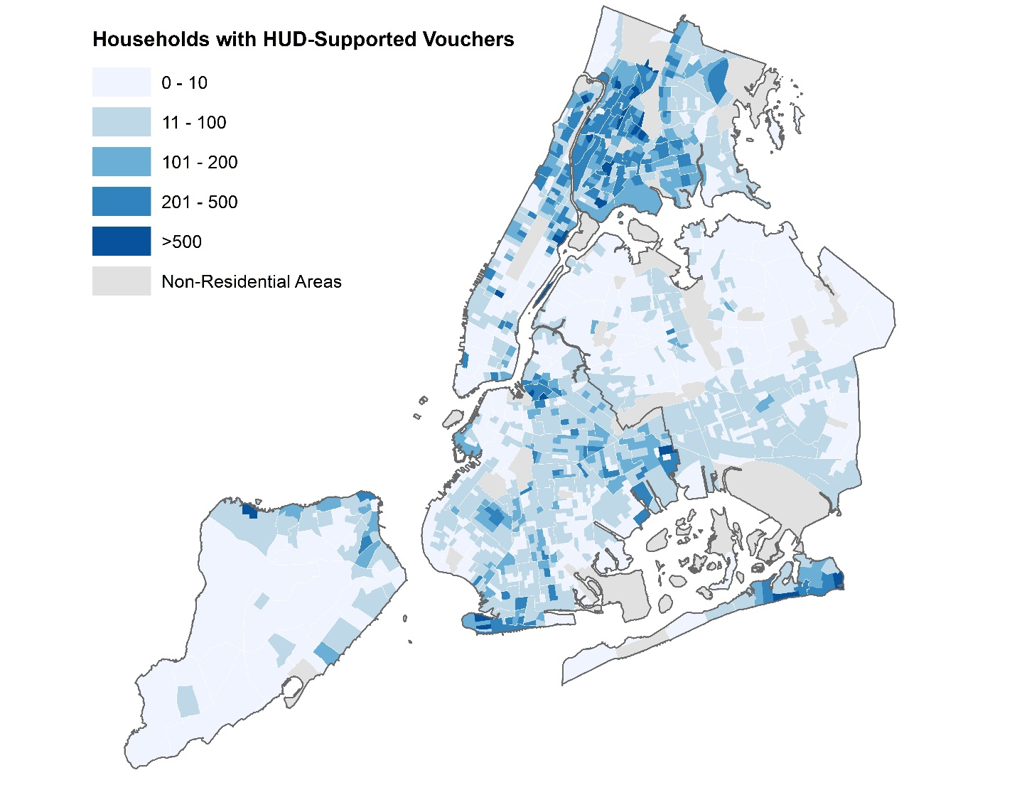
Source: HUD AFFH-T Data (AFFHT0004), from HUD PIH Information Center. Map shows the concentration of households with HUD-supported vouchers by census tract.

Goal Four Draft Strategies

Open up more housing options to New Yorkers using rental assistance
- Expand new initiative that helps residents use rental assistance to move into a greater variety of neighborhoods with good amenities: new strategies may include higher voucher payments, reimbursement for moving fees, and advising on how to choose the right neighborhood
- Link New Yorkers using rental assistance with Housing Connect (the City’s affordable housing lottery) and ensure they have the information and support they need to apply
- Expand resources to fight housing discrimination based on source-of-income, which includes vouchers and other forms of rental assistance

Improve the experience of residents and landlords participating in rental assistance programs
- Improve the design of rental assistance so that services are efficient, on time, and easy-to-use for both residents and landlords
- Better serve people with disabilities, survivors of domestic violence, and LGBTQ individuals through improved training for City staff and partners on trauma-informed care

What would this mean for you?
- Program designs to support efficient, on time, and easy􀀀to􀀀use services for participating residents and landlords
- More resources to help residents choose and move to a neighborhood that meets their needs, even in areas where using rental assistance has traditionally been difficult

Goal Five: Create more independent and integrated living options for people with disabilities
New Yorkers with disabilities face unique challenges when it comes to finding housing that is affordable, safe, and accessible. Many residents with disabilities live in institutional settings, such as nursing homes, without meaningful opportunities to live independently and interact with individuals without disabilities. A crucial part of promoting fair housing is ensuring New Yorkers with disabilities have housing options that allow them to be independent and integrated through coordinated support and more accessible options.

Why does this matter?
New York City is home to approximately 1 million people who identify as living with a disability. Throughout the Where We Live NYC process, many residents with disabilities discussed integration as something that happens within a building, as well as within a neighborhood. Most preferred to live outside of institutional settings, because they want housing that allows them to be independent and integrated into the fabric of their community. However, those who try to transition out of institutional settings struggle with red tape related to medical benefits, insurance, employment, and accessibility and discrimination in the private housing market. Despite legal requirements, more than 80% of market-rate homes in New York City require residents to use the stairs. In New York City and across the nation, discrimination against people with disabilities produces the most fair housing complaints each year.

Goal Five Draft Strategies
These strategies focus on the specific fair housing challenges facing New Yorkers with disabilities. Because people with disabilities confront many of the same issues as other New Yorkers, the other goals of Where We Live NYC are also intended to support people with disabilities.

Provide coordinated support for residents transitioning out of institutional settings
- Bring together healthcare providers, health insurance companies, housing providers, community-based organizations, and city, state, and federal government representatives to make recommendations on how to better assist New Yorkers with disabilities move from institutional settings into traditional housing

Make it easier for people with disabilities to find affordable, accessible housing
- Better connect residents with disabilities and service providers with improved online resources and trainings
- Improve City-subsidized affordable housing services to better serve the needs of people with disabilities
- Expand programs that allow seniors and people with disabilities to stay in their homes while getting their accessibility needs met
- Improve education for architects and developers so they fully follow their legal responsibilities to accommodate people with disabilities

What would this mean for you?
- Coordinated planning on how to best improve the transition from an institutional setting to independent living
- More opportunities for seniors and people with disabilities to find accessible, affordable housing or make their existing homes accessible
- Better education for architects and developers on how to make homes truly accessible

Goal Six: Make equitable investments to address the neighborhood-based legacy of discrimination, segregation, and concentrated poverty
New York City—like all cities in the United States—is scarred by a long history of discrimination, segregation, and concentrated poverty. This history has particularly impacted neighborhoods that people of color call home. Affirmatively furthering fair housing means addressing the structural disadvantages that these neighborhoods and their residents experience so that no one is deprived of high-quality resources and services because of their race, ethnicity, disability, religion, or other protected characteristic, and that residents of all neighborhoods have the resources they need to thrive.

Why does this matter?
From jobs and transit, to cultural institutions and universities, New York City is a city of opportunity. But access to these resources is not shared equally and is often connected to where New Yorkers live. The City is already working with communities to address structural disadvantages, but ongoing inequalities show that much more is required to address the legacy of discrimination, segregation, and concentrated poverty.
Inequality exists when it comes to economic opportunity, including unequal access to banks, safe lending options, quality jobs, and homeownership. These disparities are visible in how wealth is distributed in this country: nationwide, the median wealth of White families is 10 times the wealth of Black and Hispanic families. Similar disparities exist for people with disabilities.
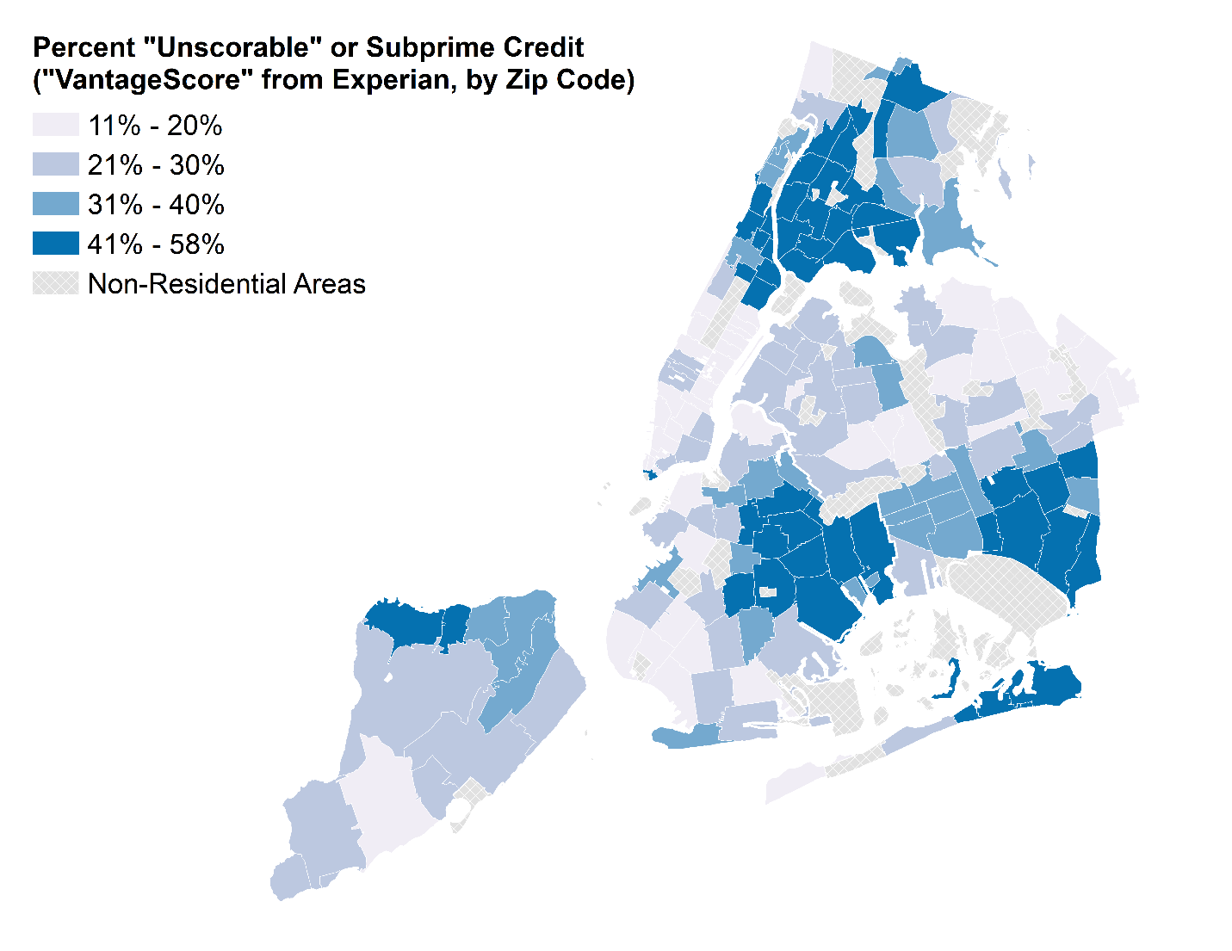
Source: New York City Comptroller (Oct 2017). Note: Credit bureaus use various scoring models to create a credit score. The data presented hare are from the “VantageScore” model, which is used by all three credit reporting agencies. In this model, specifically the “VantageScore 3.0” presented in the map, credit score ranges from 300 to 850; scores below 600 are subprime; 601 to 660 are “nonprime” and those above 660 are prime.

Inequality exists when it comes to accessing safe and healthy neighborhoods. There are stark differences in estimated life expectancy, asthma rates, and access to quality food and healthcare across the city. When it comes to safety, different neighborhoods have varying rates of violent crime and also experience the consequences of violence differently because of a history of discrimination in the criminal justice system.
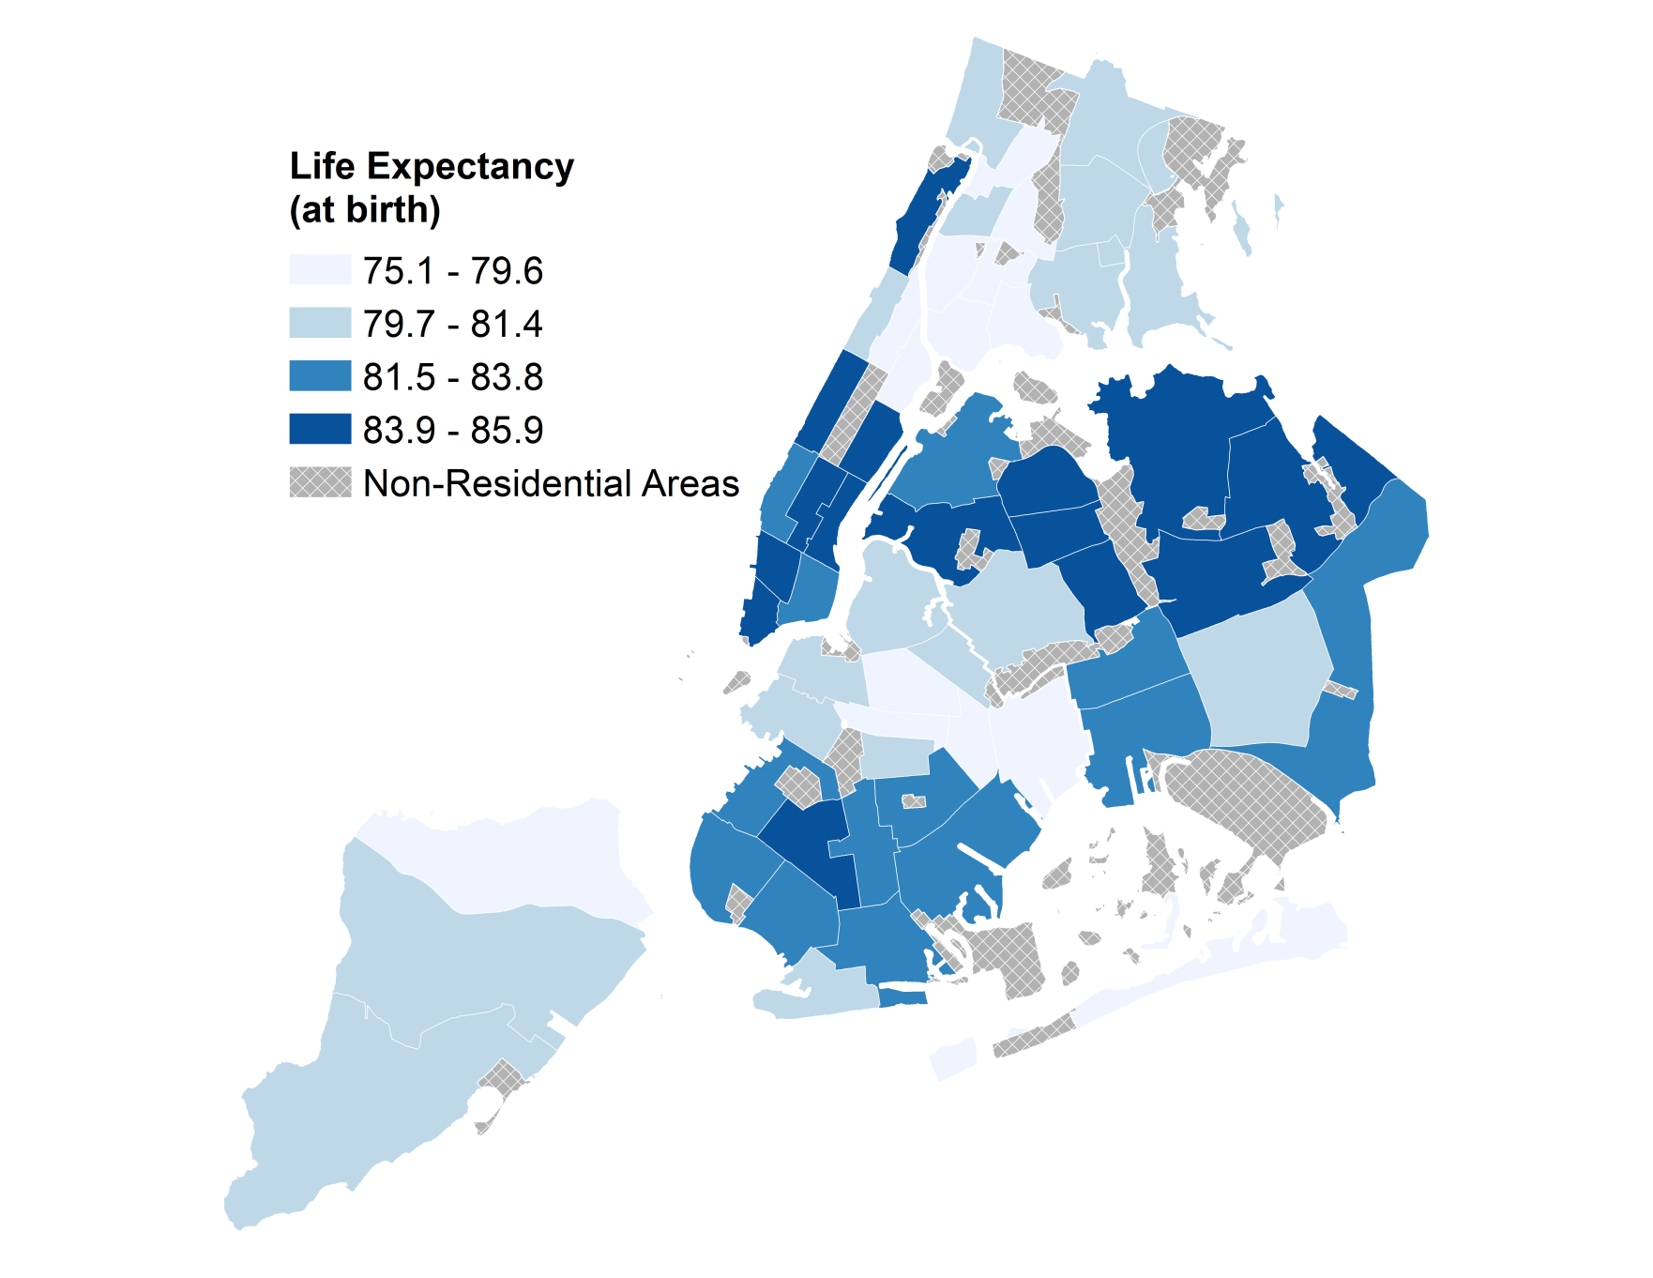
SOURCE: NYC DOHMH, Bureau of Vital Statistics, 2006—2015.

Inequality exists when it comes to accessing quality schools. While the relationship between a New Yorker’s neighborhood and their children’s access to schools is complicated, the research shows that students’ outcomes—measured by test scores, attendance, and graduation rates—vary greatly by neighborhood.
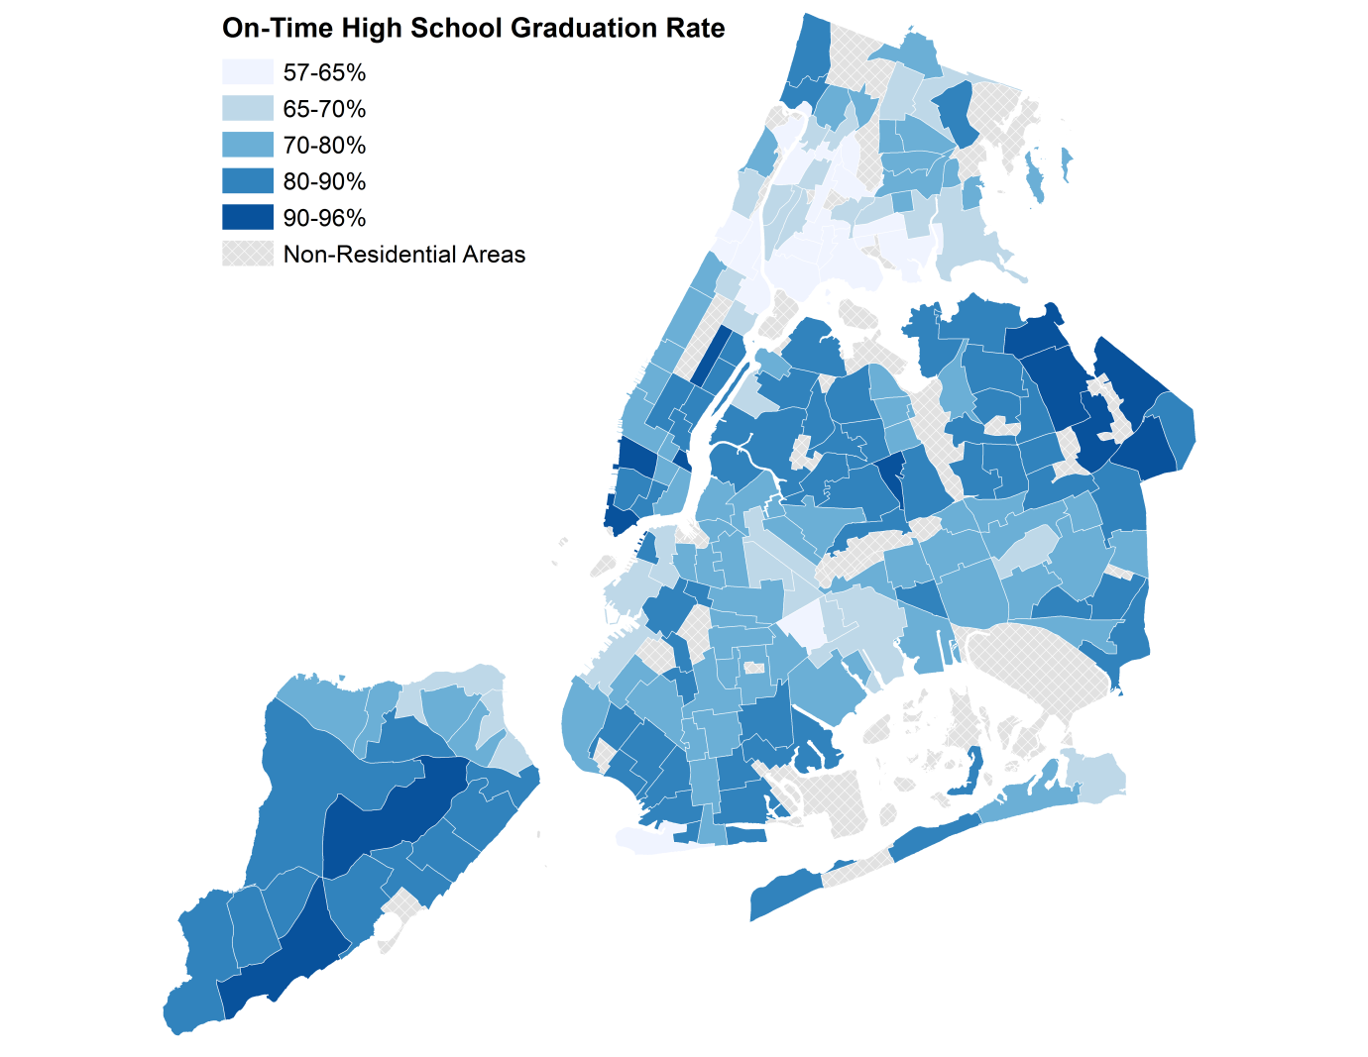
Source: Custom tabulations from the Department of Education for 2017 - 2018 school year. Includes both district and charter school students.

Inequality exists when it comes to accessing reliable and accessible transportation. New York City’s public transportation system is the largest in the country and makes it possible for New Yorkers when it comes to reliable and accessible transportation. But the transportation system faces considerable challenges, particularly with respect to serving New Yorkers with disabilities. Furthermore, not all neighborhoods have the same access to jobs: it takes five minutes more for the average Hispanic and Asian New Yorker and 10 minutes more for the average Black New Yorker to get to work, as compared to the average White New Yorker.
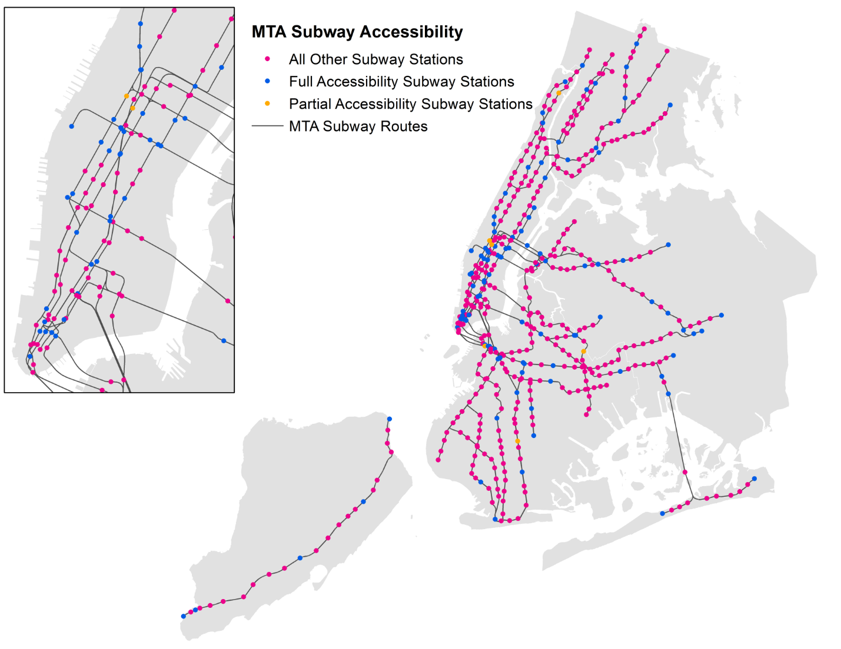
Source: Metropolitan Transportation Authority (July 2018).

Goal Six Draft Strategies

Bring equity perspectives into government decision-making
- Introduce city-wide goals and metrics for reducing disparities based on race and other social indicators
- Ensure City staff across agencies have the resources and training they need to take a race- and equity-centered approach in their work
- Ensure government decision-making is informed by a diversity of local perspectives through inclusive neighborhood planning

Work towards more diverse, integrated schools
- Create robust, community-centered diversity plans in more school districts
- Encourage a focus on diversity and integration in determining how and when school zones are redrawn
- Bring together school leaders, the real estate industry, and publications that share information on school quality to develop strategies that discourage bias and promote more accurate assessments of school performance
- Ensure that families using government housing programs are aware of the school options available when moving to new neighborhoods

Decrease neighborhood violence through restorative methods
- Ensure neighborhoods that experience the highest concentration of felony crimes have supportive services and restorative practices in place
- Make underused public spaces safer and more appealing
- for community use in neighborhoods with high rates of violent crime

Make public transportation more equitable and accessible
- Work with the MTA to increase the number of subway stations that are accessible for people with disabilities
- Support MTA efforts to improve the accessibility of station, train, and bus announcements and information for New Yorkers who have a hearing or visual disability
- Develop a plan to ensure E-hail of for-hire-vehicles are affordable for people with disabilities in a long-term and financially sustainable way
- Continue to find opportunities to make public transit more affordable for low-income households
- Facilitate faster and more reliable bus service by expanding bus priority citywide and ensuring their effectiveness through enforcement

Help New Yorkers build wealth and financial security, especially in neighborhoods with concentrated poverty
- Improve trainings and programs that help connect low-income New Yorkers, including NYCHA residents and people with disabilities, to living-wage jobs
- Help residents build credit and savings by expanding financial counseling and other tools
- Work with elected officials to re-introduce the Earned Income Disallowance in NYCHA housing, so that residents who earn additional income are not faced with immediate rent increases
- Study, expand, and improve programs focused on homeownership, wealth building, and community investment

What would this mean for you?
- A City government with better tools, resources, and measurements to take a race- and equity-centered approach
- More resources for public space, violence prevention, and financial empowerment in neighborhoods that need it most
- New strategies to help encourage more diverse and integrated schools and more accessible and affordable public transit

